Software Requirements Specification
for
Tuition Management System
Prepared by Dev Parikh
Organization: Charotar University of Science and Technology
Date Created: 02/05/2026

Table of Contents

[Note: The Table of Contents will be automatically generated when you open this document in Microsoft Word. If it doesn't appear, right-click and select 'Update Field']

1. Introduction

1.1 Purpose
The purpose of the Tuition Management System is to solve the current fees management process inefficiencies and limitations, resulting in unnecessary complexity and potential errors, by providing a more streamlined and effective way to manage fees, thereby reducing the associated administrative burdens and improving accuracy.

1.2 Intended Audience
This document is intended for:
- End Users
- Managers
- Developers
- Project Managers

1.3 Project Scope

Included in scope:
- Manage attendance records
- Process and track fees

Excluded from scope:
- Hardware manufacturing
- Third-party marketing

1.4 Document Conventions
- Standard IEEE formatting
- Bold text for UI elements

1.5 References
- REF-1: GDPR Compliance Guidelines
- REF-2: HIPAA Compliance Requirements

2. Overall Description

2.1 Product Perspective
A standalone Mobile Application for the Telecom sector, as specified in the project identity.

2.2 Product Features
- Manage attendance records
- Process and track fees

2.3 User Classes and Characteristics

End User
- Frequent use of mobile applications
- Basic technical knowledge

Manager
- Advanced technical knowledge
- Frequent monitoring of attendance and fees

2.4 Operating Environment
- On-Premise deployment with Python backend and SQL database

2.5 Design and Implementation Constraints
- Compliance with GDPR and HIPAA regulations
- Use of Python as the preferred backend
- Use of SQL as the database preference
- On-Premise deployment

2.6 User Documentation
- User Manual
- API Documentation

2.7 Assumptions and Dependencies

Assumptions:
- Users have basic technical knowledge to operate the application

Dependencies:
- Reliable internet connection for mobile application usage
- SQL database for data storage

3. System Features

3.1 Attendance Record Management
Description: Manages and tracks user attendance records.

Stimulus/Response Sequences:
Stimulus: User marks their attendance
Response: System updates the attendance record in the database.

Functional Requirements:
- The system shall store attendance records in the SQL database.
- The system shall provide a user interface for users to mark their attendance.

3.2 Fees Processing and Tracking
Description: Processes and tracks user fees.

Stimulus/Response Sequences:
Stimulus: User initiates a payment process
Response: System generates a payment transaction and updates the fees record.
Stimulus: User completes the payment transaction
Response: System updates the payment status and sends a confirmation notification.

Functional Requirements:
- The system shall integrate with a payment gateway to process transactions.
- The system shall update the fees record in the database upon successful payment.
- The system shall send a confirmation notification to the user upon successful payment.

3.3 User Authentication
Description: Authenticates users before allowing access to the system.

Stimulus/Response Sequences:
Stimulus: User attempts to log in
Response: System verifies the user credentials and grants access if valid.

Functional Requirements:
- The system shall implement authentication using a secure protocol.
- The system shall store user credentials securely in the database.

External Interface Requirements

User Interfaces
Purpose: Provides the primary interaction points for End Users and Managers to access tuition fee processing and attendance management via a mobile application.\nTechnology Stack: React Native (v0.73) for iOS/Android, Redux for state management, Axios for HTTP calls.\nData Format: JSON over HTTPS (TLS 1.3).\nAuthentication: OAuth 2.0 Authorization Code flow with PKCE, issuing JWT access tokens validated by the Authentication Service.\nPerformance Characteristics: Expected UI response <200 ms for API calls, concurrent mobile sessions up to 1 000 users, connection pool size 100 per service.\nError Handling: Global error interceptor with exponential back‑off retries (max 3 attempts), fallback UI messages, circuit‑breaker pattern via Redux‑Saga.

User Interface Architecture:
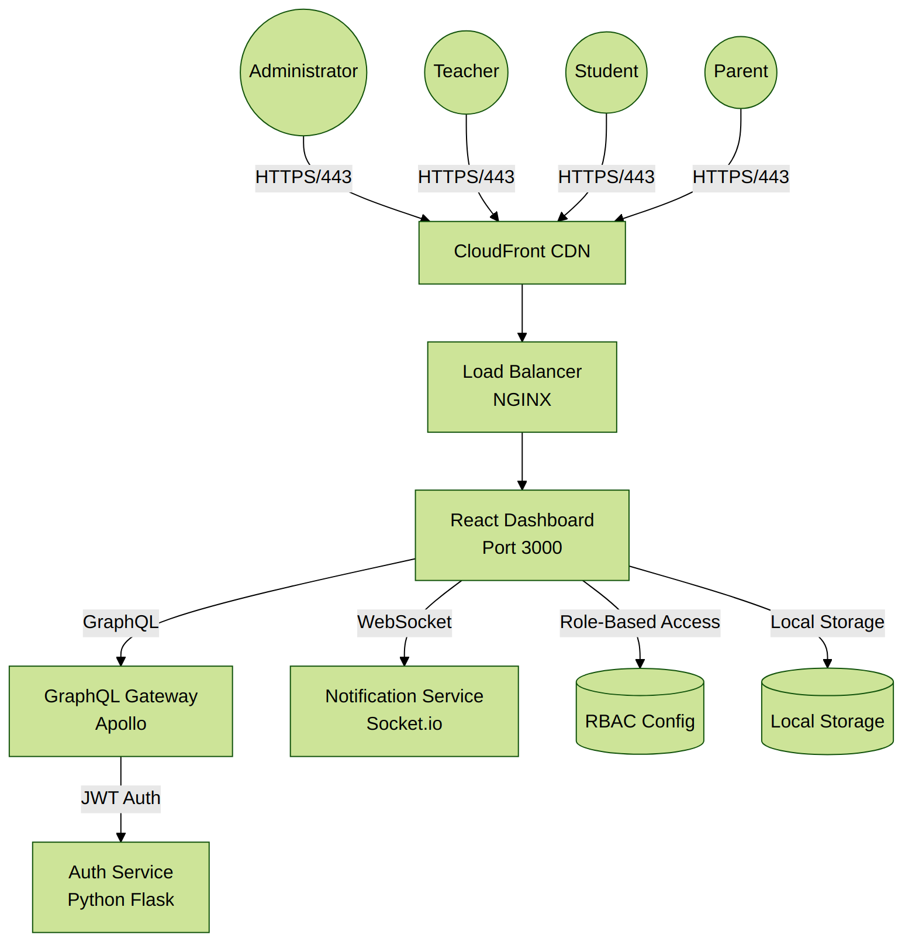

Hardware Interfaces
Details to be defined during technical design phase. The current solution does not require dedicated hardware peripherals; any future integration (e.g., biometric attendance scanners) will be captured here.

Hardware Interface Architecture:
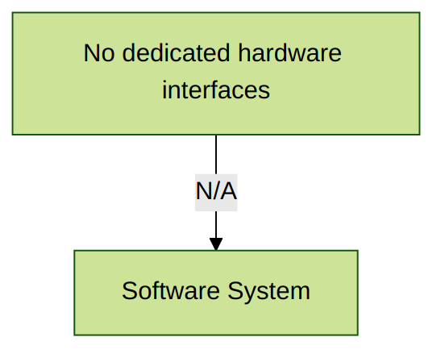

Software Interfaces
Purpose: Defines all external software components and services the system depends on for authentication, payment processing, data persistence, caching, and asynchronous task handling.\nTechnology Stack: Python 3.11 backend (FastAPI), PostgreSQL 15, PgBouncer for connection pooling, Redis 7.0, RabbitMQ 3.11, Stripe API, OpenLDAP for directory services, Kong API Gateway.\nData Format: JSON for REST endpoints, JWT for auth tokens, AMQP for message queues.\nAuthentication: OAuth 2.0 for user login, API keys for Stripe, LDAP bind for internal service auth.\nPerformance Characteristics: PostgreSQL connection pool max 200, Redis latency <1 ms, RabbitMQ throughput >10 k msgs/s, Stripe API latency ~300 ms.\nError Handling: Retry policies on Stripe (3 attempts with jitter), dead‑letter queue for RabbitMQ, fallback to read‑replica on DB read failures, circuit breaker on external services.

Software Interface Architecture:
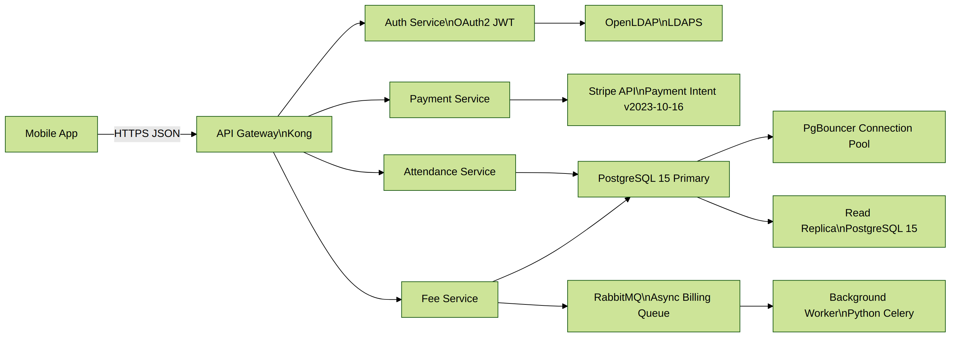

Communication Interfaces
Purpose: Describes the network and transport layers that connect external users and services to the internal system.\nTechnology Stack: Internet traffic enters via a perimeter firewall, TLS 1.3 termination at HAProxy load balancer, Kong API Gateway for routing, rate limiting, and request validation. Internal services communicate over a private LAN using HTTP/2 and gRPC where appropriate.\nSecurity Layers: Mutual TLS (mTLS) between load balancer and API gateway, JWT validation at gateway, LDAP over LDAPS for directory queries.\nPerformance Characteristics: Load balancer supports 10 Gbps, API gateway enforces 200 req/s per client, latency budget <150 ms for internal service calls.\nError Handling: HAProxy health checks with automatic failover, Kong circuit‑breaker plugin, fallback to cached responses from Redis, alerting via Prometheus alerts.

Communication Interface Architecture:
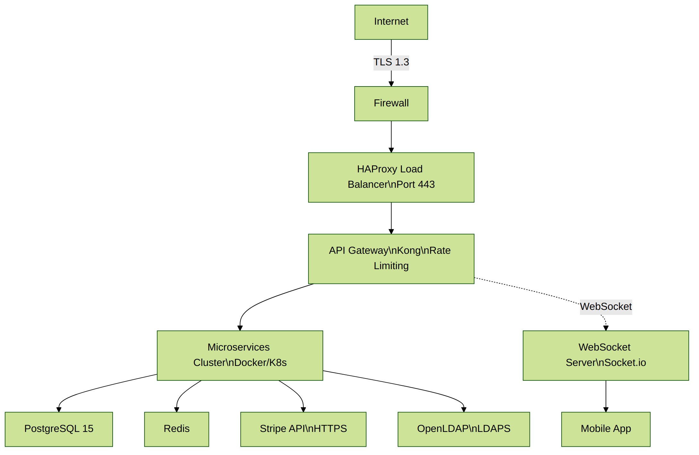

5. Non-Functional Requirements

5.1 Performance Requirements
- The system shall support 100-1,000 concurrent users without performance degradation.
Rationale: To accommodate expected peak traffic during marketing campaigns.
- The system shall respond to user requests within 2 seconds under normal load.
Rationale: To ensure a responsive user experience and meet industry standards.

5.2 Safety Requirements
- The system shall perform automated daily backups of all user data.
Rationale: To prevent data loss in case of system failure or corruption.

5.3 Security Requirements
- The system shall implement OAuth 2.0 for user authentication.
Rationale: To provide secure and industry-standard authentication mechanism.
- The system shall comply with GDPR and HIPAA regulations.
Rationale: To ensure the protection of sensitive user information.

5.4 Quality Attributes
- The application must achieve 99.9% uptime.
Rationale: To ensure reliability for enterprise-level clients.
- The system shall be maintainable with modular architecture and comprehensive documentation.
Rationale: To enable efficient updates and reduce long-term maintenance costs.

6. Glossary

6.1 Acronyms and Abbreviations
GDPR: General Data Protection Regulation - EU regulation on data protection and privacy for individuals.
HIPAA: Health Insurance Portability and Accountability Act - US legislation providing data privacy and security provisions for safeguarding medical information.
OAuth 2.0: Open Authorization 2.0 - industry-standard protocol for authorization used for secure authentication.
IEEE: Institute of Electrical and Electronics Engineers - professional association that develops standards for formatting.
API: Application Programming Interface - set of protocols and tools for building software applications.
SQL: Structured Query Language - standard language for managing and manipulating databases.

6.2 System Components
Tuition Management System: Mobile application designed to streamline fees management and attendance tracking.
Attendance Record Management: System feature that manages and tracks user attendance records in the database.
Fees Processing and Tracking: System feature that processes payments and maintains records of user fees.
Payment Gateway: Third-party service integrated to process payment transactions securely.
User Authentication: System component that verifies user credentials before granting access.

6.3 Technologies
Python: Preferred backend programming language for developing the system.
Mobile Application: Software application designed to run on mobile devices.
On-Premise Deployment: Deployment model where software is installed and runs on local servers.
Backend: Server-side component that handles data processing and business logic.

6.4 Performance Metrics
Concurrent Users: Number of users using the system simultaneously - system supports 100-1,000 users.
Response Time: Time taken by system to respond to user requests - target of 2 seconds under normal load.
Uptime: Percentage of time system is operational and accessible - requirement of 99.9% uptime.
High Performance: System capability to handle operations with high speed and efficiency.

6.5 Security Terms
Authentication: Process of verifying user identity before granting access to the system.
Data Encryption: Method of protecting data by converting it to unreadable format.
Compliance: Adherence to regulatory requirements such as GDPR and HIPAA.

6.6 Quality Attributes
Maintainability: System characteristic enabling efficient updates through modular architecture and documentation.
Reliability: System characteristic ensuring consistent performance and minimal downtime.
Availability: Percentage of time the system remains operational and accessible to users.

6.7 User Roles
End User: Primary system user who uses mobile applications with basic technical knowledge.
Manager: Advanced user role with technical knowledge who monitors attendance and fees.
Developer:

7. Assumptions

Assumption 1:
Users have basic technical knowledge to operate the mobile application.
Impact: If users lack basic technical knowledge, additional training programs and simplified UI/UX would be required, increasing project costs and extending the rollout timeline.

Assumption 2:
The organization has an existing infrastructure that can support On-Premise deployment with Python backend and SQL database.
Impact: Without such infrastructure, significant upfront investment in hardware and software would be required, potentially delaying project start and increasing costs.

Assumption 3:
The third-party payment gateway will maintain 99.9% uptime as per their SLA.
Impact: If the payment gateway experiences significant downtime, the system would be unable to process transactions, leading to user dissatisfaction and potential revenue loss.

Assumption 4:
Users will access the system primarily through modern devices and browsers.
Impact: Supporting older devices and browsers would require additional development effort, testing, and potential limitations in functionality.

Assumption 5:
The system will be deployed on-premise with reliable internet connectivity.
Impact: Inadequate internet connectivity could lead to system downtime, impacting user access and overall system performance.

Assumption 6:
Regulatory requirements for data privacy (GDPR, HIPAA) will remain stable during development.
Impact: Changes in data privacy regulations could necessitate significant architectural changes, additional compliance features, and potential project delays.

